# Eksamen 2023

By Jesper Graungaard Bertelsen, AU-ID: au689481

Indholdsfortegnelse

Eksamen 2023 1

Opgave 1 2

a. Compute the Fourier transform $Mf$ of the message signal. Sketch the spectrum. Write in the sketch the key amplitudes and frequencies. 2

b. What’s the Nyquist sampling frequency? Sketch the spectrum S(f) considering that fs = 2 kHz from −10 kHz to 10 kHz. Write in the sketch the key amplitudes and frequencies. [7 Points] 2

c. The signal is then fed into a uniform quantizer of the midrise type. The total number of representation levels L = 32. Calculate the power of the quantization noise σQ2 . [7 Points] 3

d. Modulate the quantized signal using BPSK: ’-1’ and ’1’. Transmit it over an AWGN channel with noise power σN2 . What’s the error probability $Pe$ when symbol ’1’ is transmitted? [7 Points] 4

Opgave 2 7

Opgave 3 8

Opgave 4 9

## Opgave 1

For a message signal

$$m\left(t\right)=10\sin\left(2π·800t\right)+2\cos\left(2π·1800t\right)$$

### Compute the Fourier transform $M\left(f\right)$ of the message signal. Sketch the spectrum. Write in the sketch the key amplitudes and frequencies.

Fourier transform is a linear operator so I can just take the Fourier transform of all the parts and add them together afterwards.

Using the linearity property as well.

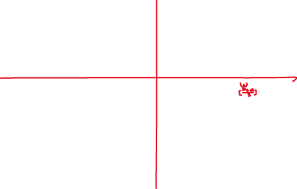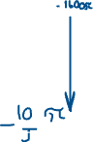

### What’s the Nyquist sampling frequency? Sketch the spectrum S(f) considering that fs = 2 kHz from −10 kHz to 10 kHz. Write in the sketch the key amplitudes and frequencies. [7 Points]

As the frequencies are going from $-1800Hz→1800Hz$, the bandwidth is then

$$B=3600Hz$$

The nyquist rate would then be twice the bandwidth.

$f_{nyquist}=7200Hz$

Now sketching it:

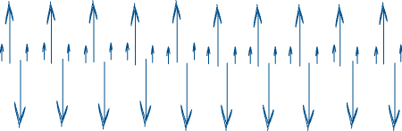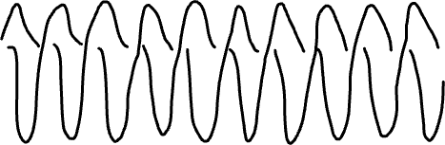

With the switching curves I’ve drawn it should be easier to see that with this sample frequency, the signals would overlap.

### The signal is then fed into a uniform quantizer of the midrise type. The total number of representation levels L = 32. Calculate the power of the quantization noise σQ2 . [7 Points]

As it’s a uniform quantizer of the midrise type doesn’t affect the power for us.   
Midrise just centers within two levels, whilst the midtread is put at a level.  
  
For both of these the average signal noise power can be calculated from:

$$σ_{Q}^{2}=\frac{∆^{2}}{12} <-Formel 7.39$$

In where ∆ being the step size.

The step size can be calculated from

$$∆=\frac{2A_{max}}{2^{R}}=\frac{2A_{max}}{L}$$

Where $R$ is the amounts of bits required to represent these amounts of levels *L*.

$$A_{max}=\left(10+2\right) <-The situation with constructive interference$$

$$R=\log_{2}\left(32\right)$$

$$∆ =\frac{2·12}{32}=0,75$$

The power of the quantization noise is then.

====================

$σ_{Q}^{2}=\frac{{\left(0,75\right)}^{2}}{12}=0,046875$

====================

### Modulate the quantized signal using BPSK: ’-1’ and ’1’. Transmit it over an AWGN channel with noise power σN2 . What’s the error probability $P_{e}$ when symbol ’1’ is transmitted? [7 Points]

So I’ve been implementing it all in matlab.   
As the way we plot on computers are by a discrete array, we are already using sampling.

I am then just making an array at every $T_{s}$ from 0 -> 10ms

I then make the quantization sequence with levels ranging from $\left[-16;16\right]$, by taking the amplitude, dividing it by the step height, and finding the nearest level.

To make it a signal again the level * the height pr. Level, aka the delta can be assigned to a variable.



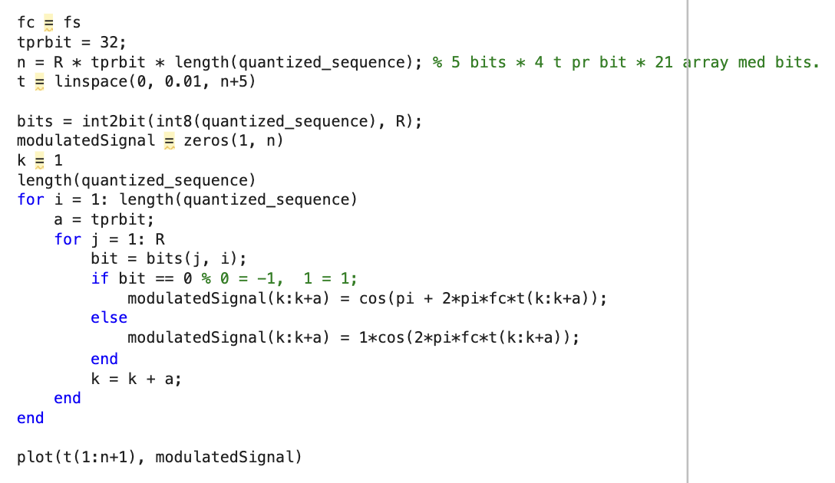For the BSPK modulation I iterated over every bit sequence, over every bit. If it were a 0 I added function values of size $t_{points}$ to an array of BPSK modulated values



$$s_{0}\left(t\right)=-A_{c}·\cos\left(2πf_{c}t\right)∈R^{1×t_{points}}$$

Equivalent to

$$s_{0}\left(t\right)=A_{c}·\cos\left(2πf_{c}t+π\right)∈R^{1×t_{points}}$$

For the bit being 1 I added the function values of value

$$s_{1}\left(t\right)=A_{c}·\cos\left(2πf_{c}t\right)∈R^{1×t_{points}}$$

$t_{points}$ being a value of I added, for the plot not two be of a single point for every bit, but rather a wave form. As I didn’t get any wanted carrier frequency, I set my carrier frequency equal to the sample frequency.

Plotting it with the time points for every bit set two 32:

With a full plot on the right and zoomed in on what looks like one fundamental period.

Now wanting to add noise of AWGN I use the matlab command for awgn which takes in a vector, and a SNR, and returns and array with noise.

When plotted I get a signal identical to the one without noise. It’s weird that it’s as identical to the nonnoise signal. But I guess, that it had a large SNR of 1533 and SNRdB of about 63, which is pretty high and can justify tself even hswgint aoisle nl ookinglike it

## Opgave 2

## Opgave 3

## Opgave 4